Johan Öhman Saldes system developer

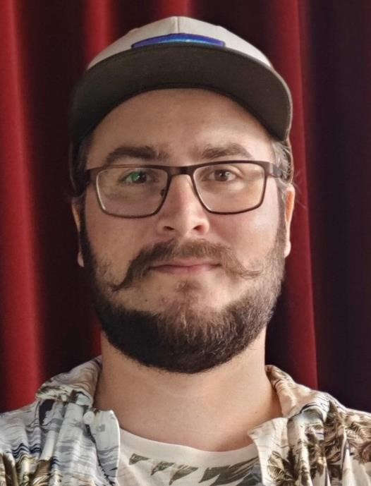Johan is a passionate developer with a wide experience of development both in the frontend and the backend. He has worked with a variety of languages such as Golang, Rust, TypeScript, and Elixir to mention a few.

His strengths are his wide experience, his curiosity, and focus on getting things done. He’s not prestigious but rather focus on what need to be done. His curiosity is what pushes him to always learn new things and he’s often actively developing some hobby projects to evaluate new technology and frameworks.

Johan is a social and positive co-worked, he gets into new teams quickly and loves to share a laugh. He is team oriented and has experience delivering under own responsibility.

Johan fits in a pure developer role but could also take on a tech lead or mentoring role. Johan has experience working open source, and therefore experience working with many of the latest tools.

Skills

# Language & Frameworks

**JavaScript**, Rust, NodeJS, **TypeScript**, **React**, NextJS, Golang

# Methodologies

Scrum, CI/CD, Micro services, Serverless, MVVM, Open source

# Platforms

Micro services, Docker, AWS, Kubernetes,

OpenStack, Azure, Canvas, Edge@Computing

**DevOps**

Gitlab, Azure, Github, Vercel, Circle CI, Travis CI, Docker compose, Nagios, Graphana,

Prometheus, AlertManager, Graylog, Kibana,

Jenkins, GCloud

# Databases

MongoDB, Elastic Search, PostgreSQL, MySQL,

MS SQL, Oracle, Redis, BigQuery

# Tools & misc

Drupal, Sketch, Git, Styled Components,

Canvas CMS, BankID

Experience

# Tele2, 2023 – 2024

## Frontend developer

Developed frontend for the video streaming platform Tele2 Play. I developed new features and helped come up with new features. I converted their frontend from JavaScript to TypeScript. I was also responsible for a11y implementations.

*Techstack: NextJS, React, TypeScript, Tailwind, a11y accessibility*

# IKEA, 2022 - 2023

## Backend developer

Worked in two teams. One was working with internal documentation and tooling, used React et al. The other was about migrating from Akamai to Fastly. The first was more frontend and took about <10% of my time. The rest was backend with Golang, Rust and WASM.

*Techstack: WASM, Rust, Golang, TinyGo, GCloud, Edge@Computer, Typescript, NextJS*

# H&M, 2021-2022

## Frontend developer

I developed components for content to drive traffic for H&M. I was active in the migration from legacy to NextJS. Was active in the internal development community where we discussed improvements to the platform on more large levels.

*Techstack: React, Typescript, Javascript, NextJS, React Testing Library, Azure, Storybook, Optimizely, Figma*

# KTH, 2020

## Backend developer

Primarily NodeJS development to automate things from correcting tests, engaging with the community and other CMS related functionality. We developed a lot using HATEOS principles and everything was open source.

*Techstack: NodeJS, Canvas CMS, micro services, open source, React, ES6, Graphana, Prometheus, Jenkins, AVA, Rust*

**Bouvet, 2019**

## Fullstack developer

Worked as a consultant.

*Techstack: NodeJS, React, BankID,*

***AWS****, IAM, ES6, Webpack, ExpressJS*

**House of Radon, 2019**

## Frontend developer

NextJS development using TypeScript. Worked with hooks, pixel perfection, UI/UX design, headless CMS with Contentful and later Prism.

*Techstack: React, NextJS, Typescript,*

*Serverless, Webpack, Vercel*

# Edgeware, 2019

## Frontend & DevOps

Developed a frontend for an application that analysed video streams in real time. Used a lot of graphs to represent data as it came in.

*Techstack:* ***AWS****, React, Typescript, Hooks*

*API, Ant Design, Webpack, ChartJS, Docker*

# Inovia, 2017 – 2019

## Frontend & DevOps

Primarily consultant. Worked part time with R&D development. Developed a chat bot together with AI/CompSci engineers.

*Techstack: Kubernetes, Terraform, Gitlab-CI, React, TypeScript.*

# Ericsson, 2017 – 2018

## Frontend & DevOps

Developed PaaS to integrate agile development into Ericsson. Developed platform to run start up styled project quickly.

*Techstack: React, Redux, Typescript,*

*Sass, Docker, micro services, Kubernetes,*

*Scrum, Agile, PaaS, Gitlab CI, Terraform*

# 

# Visit Technology Group, 2017

## Fullstack developer

Developed VueJS frontend for an Elastic Search driven search function to replace Google Search widgets.

*Techstack: Drupal, PHP, VueJS, Elastic*

*Search, Kibana, Travis CI*

# Bearcom, 2016 - 2017

## Fullstack developer

Developed frontend and backend to manage OpenStack for a server hall. We handled about 200 racks.

*Techstack: JavaScript, Openstack, VueJS, Golang, Python, Django*

**Hosono, 2015 - 2017**

## Fullstack developer

Developed several custom websites solutions for digital marketing, content marketing and more.

*Techstack: NodeJS, Golang, PostgreSQL, VueJS, Javascript, jQuery, Nagios*